How to Hide a Course on the OLS
- Go to Daily Plan

- Go to Schedule Set-up
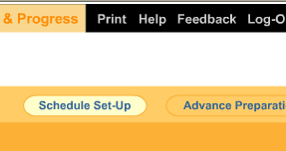

- Click on NEXT
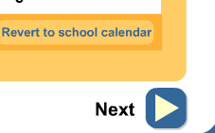
- Click on SHOW/HIDE Course in Plan in left hand corner.
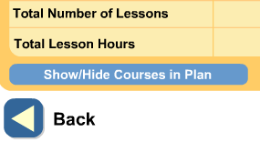
- Uncheck Spelling or Phonics
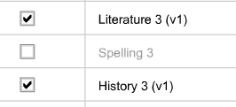

- Once Spelling or Phonics is unchecked it will no longer show up on your daily plan.

